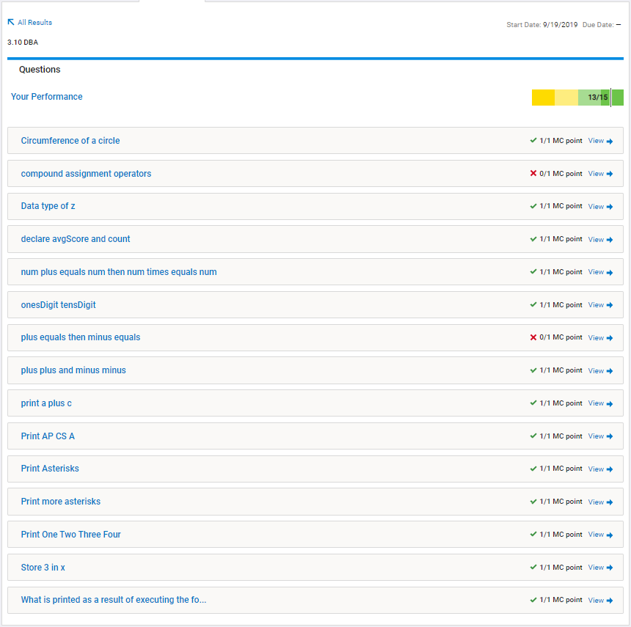**Paste an image of your results from AP Classroom below**

**Questions I got Wrong and Why**

|  |  |
| --- | --- |
| Question Number and Topic | Mistake or misunderstanding I had |
| Question #2 - Compound Assignment Operators | I forgot to divide using integer division rather than floating point division |
| Question 7 - += then +- | I made my answer as if x were a double, rather than an integer. |

**Now that you’ve reviewed all of your errors, what will you need to remember to be successful with similar questions on the AP exam?**

I learned that I need to be more attentive to the data types of variables, especially when doing math.